Project Design Phase-II
Data Flow Diagram & User Stories

Date | 03 August 2026
Team ID | NA
Project Name | Book A Doctor
Maximum Marks | 4 Marks

Data Flow Diagrams:
A Data Flow Diagram (DFD) illustrates how data moves through the Book A Doctor system. It shows the interaction between Patients, Doctors, and Admin with the application, the processing of requests, and the storage of information in the database. The DFD also represents the flow of appointment, payment, and notification data between the system and external services.

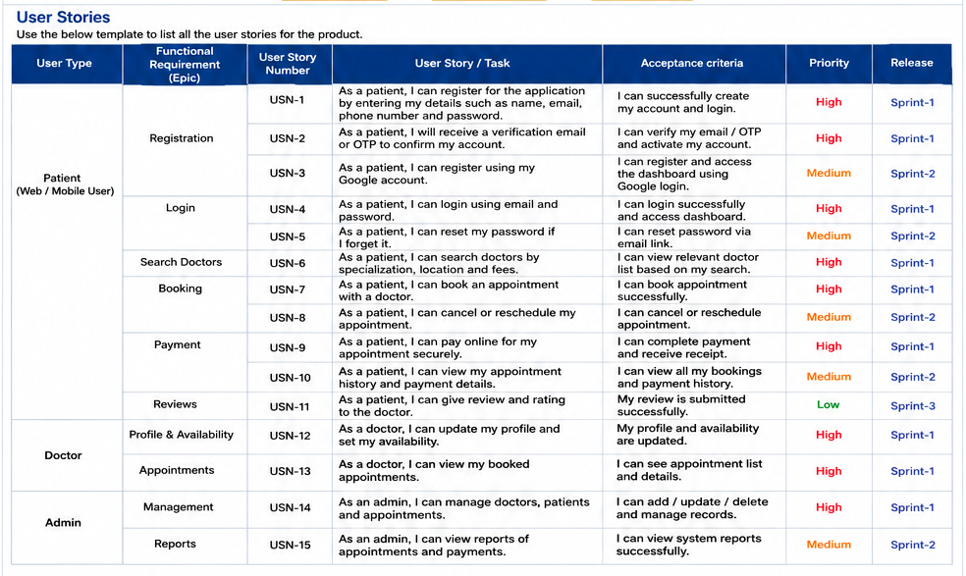

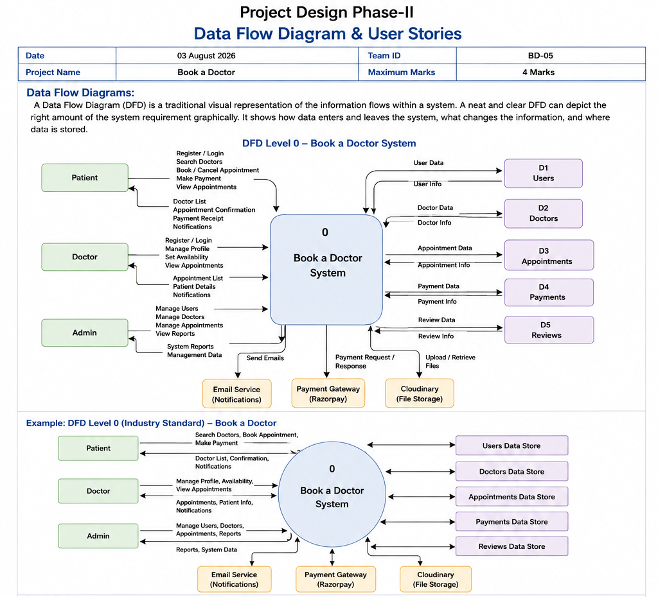

User Stories
User Type | Functional Requirement (Epic) | User Story Number | User Story / Task | Acceptance Criteria | Priority | Release
Patient (Web/Mobile User) | Registration | USN-1 | As a patient, I can register using my name, email, phone number and password. | I can successfully create my account. | High | Sprint-1
Patient (Web/Mobile User) | Registration | USN-2 | As a patient, I receive a verification email or OTP after registration. | My account is verified successfully. | High | Sprint-1
Patient (Web/Mobile User) | Login | USN-3 | As a patient, I can log in using my email and password. | I can access my dashboard securely. | High | Sprint-1
Patient (Web/Mobile User) | Search Doctors | USN-4 | As a patient, I can search doctors by specialization, location and experience. | I receive relevant doctor results. | High | Sprint-1
Patient (Web/Mobile User) | Appointment Booking | USN-5 | As a patient, I can book an appointment with an available doctor. | Appointment is confirmed successfully. | High | Sprint-1
Patient (Web/Mobile User) | Appointment Management | USN-6 | As a patient, I can cancel or reschedule my appointment. | Appointment details are updated correctly. | Medium | Sprint-2
Patient (Web/Mobile User) | Payment | USN-7 | As a patient, I can make online payments for appointments. | Payment is completed and receipt is generated. | High | Sprint-1
Patient (Web/Mobile User) | Reviews | USN-8 | As a patient, I can submit ratings and reviews for doctors. | My review is saved successfully. | Medium | Sprint-2
Doctor | Profile Management | USN-9 | As a doctor, I can update my profile and consultation timings. | Profile changes are saved successfully. | High | Sprint-1
Doctor | Appointment Management | USN-10 | As a doctor, I can view and manage booked appointments. | Appointment list is displayed correctly. | High | Sprint-1
Administrator | User Management | USN-11 | As an administrator, I can manage patients, doctors and appointments. | Records can be added, updated and removed. | High | Sprint-1
Administrator | Reports | USN-12 | As an administrator, I can view appointment and payment reports. | Reports are generated successfully. | Medium | Sprint-2

